PBL MINIPROJECT REPORT
SY CSE Panel E
Batch-Group Number :- E1-2
Team Members:
Member 1 : Divyesh Jha (09)
Member 2 : Rushikesh Parit (04)
Member 3 : Aaditya Sharma (20)
Member4 : Nikhil Sinha (27)

Table of contents

- Abstract
- Introduction
- Implementation
- Block Diagram/Logic Diagram
- Explanation of Components
- Hardware Specifications
- Software Specifications
e) Algorithm
4) Conclusion and Result
5) Conclusion
6) References

Abstract:
The project involves designing a frequency generator that utilizes a Digital-to-Analog Converter (DAC) and an oscilloscope to produce various waveforms, specifically square, sine, and ramp waves. The primary problem addressed is the need for an efficient and user-friendly tool for generating precise waveforms for testing and educational purposes.
The solution incorporates a keypad for user input, allowing users to select the desired waveform and its frequency. The microcontroller processes this input and drives the DAC to generate the corresponding analog signal, which is then displayed on the oscilloscope for visualization.
Key outcomes include the successful implementation of all three waveforms, demonstrating the versatility and reliability of the frequency generator. The project enhances understanding of waveform generation and DAC functionality while providing a practical tool for experimentation in electronics. Additionally, the user interface is designed for simplicity, ensuring that users can easily modify parameters and observe real-time results, making it an effective educational resource.

Introduction:
The 8051 Microcontroller is a versatile and widely used embedded system known for its simplicity and effectiveness in controlling various applications. One of its intriguing applications is wave generation, which involves creating different signal forms such as square, triangular, and sine waves.

Motivation:
1) Understanding wave generation enhances knowledge of digital signal processing and microcontroller programming.
2) Waveforms are essential in testing electronic circuits, audio applications, and modulation techniques in communication systems.
3) Utilizing the 8051 Microcontroller for wave generation is an economical approach for developing various electronic projects without the need for expensive equipment.
4) The microcontroller allows for easy modification of frequency, amplitude, and waveform shape, catering to diverse project requirements

Implementation:
Block Diagram/Logic Diagram:
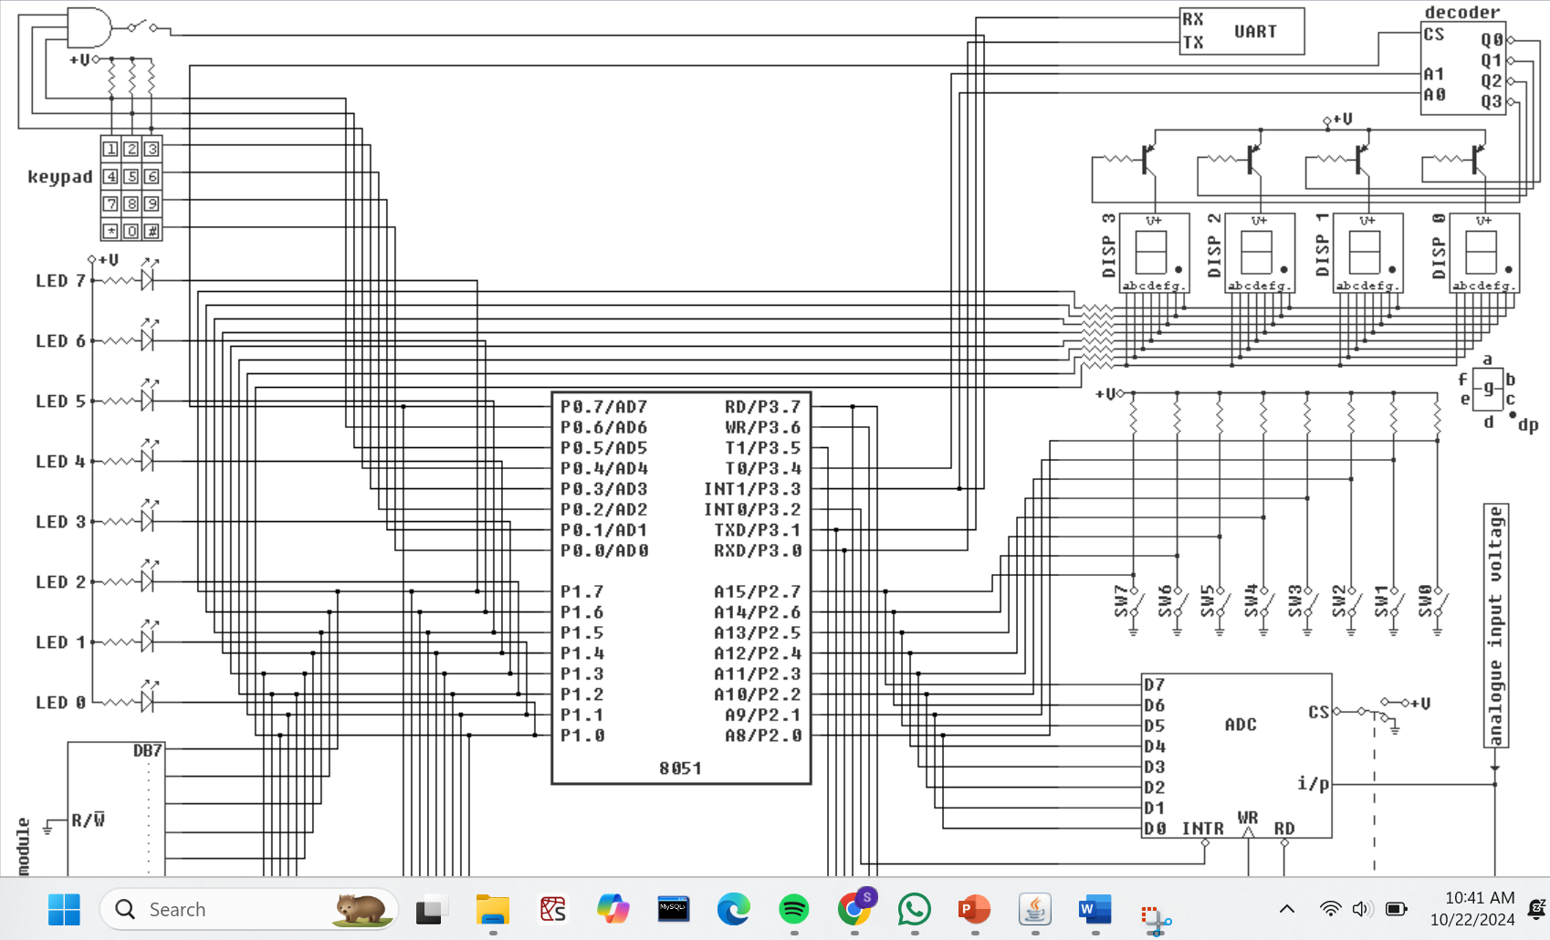

The system comprises several major components:
8051 Microcontroller: Central unit responsible for managing user inputs and controlling the DAC to generate waveforms.
DAC (Digital to Analog Converter): Converts digital values from the microcontroller into analog signals (waveforms).
Oscilloscope: Used to observe and verify the waveforms generated by the system.
Keypad: Input device through which the user selects the type of waveform (Ramp, Square, Sine).
Power Supply: Provides the necessary power to the system components.
Block Diagram:

Explanation of Components:
8051 Microcontroller:
Controls the flow of operations. It receives user input via the keypad, processes the signal, and sends digital values to the DAC based on the waveform selected.
Interacts with the DAC using a serial or parallel data transfer method, depending on the specific DAC model.
DAC (Digital to Analog Converter):

Converts the binary output from the microcontroller into an analog voltage. The microcontroller provides appropriate digital codes corresponding to different points in the waveform (e.g., sine wave points).

Keypad:
User interface for selecting the desired waveform. The user presses keys (1 for Ramp, 2 for Square, and 3 for Sine), and the microcontroller interprets these inputs accordingly.
Oscilloscope:
Displays the analog waveform generated by the DAC for verification. The user can view the waveforms in real-time and confirm the accuracy of the wave generation process.
Power Supply:
Provides the necessary voltage (5V for the microcontroller and related circuitry).

Main Program Start
ORG 0000H
JMP Begin ; Jump to main scan loop
GenerateRamp:
;Waveform Generation Routine
CLR P0.7 ; Enable DAC for Ramp
MOV P1, #7FH ; Initial midpoint value
MOV A, #00H ; Starting value for ramp
RampLoop:
MOV P1, A ; Output ramp to DAC
INC A ; Increment the ramp value
SJMP RampLoop ; Loop indefinitely (replace with delay if needed)

GenerateSquare:
CLR P0.7 ; Enable DAC for Square
SquareLoop:
MOV A, #00H ; Low signal
MOV P1, A
CALL DELAY ; Delay
MOV A, #0FFH ; High signal
MOV P1, A
CALL DELAY ; Delay
SJMP SquareLoop ; Loop indefinitely

GenerateSine:
CLR A ; Clear accumulator for sine
UP: MOV DPTR,#SINE
MOV R0,#24
CLR P0.7; enable the DAC write line
LABEL: MOVC A,@A+DPTR
MOV P1,A
CLR A
INC DPTR
DJNZ R0,LABEL
SJMP UP

ORG 050H
SINE:
DB 127,160,191,217,237,250,255,250,237,217,191,160,127,94,63,37,17,4,0,4,17,37,63,94,127

SineLoop:
MOV DPTR, #SINE ; Load sine table
MOV R0, #24 ; 24 values in the sine table
CLR P0.7 ; Enable DAC

SineLabel:
MOVC A, @A+DPTR ; Read sine value from table
MOV P1, A ; Output sine wave to DAC
INC DPTR ; Move to next table entry
DJNZ R0, SineLabel ; Repeat for all sine values
SJMP SineLoop ;Repeat the sine wave

DELAY: ; Simple delay subroutine
MOV R2, #0FH
DelayLoop:
DJNZ R2, DelayLoop
RET

; Main keypad scanning and user input handling
Begin:

CLR P0.3 ; Scan Row3
CALL IDCode0
JB F0, SelectWaveform

CLR P0.2 ; Scan Row2
CALL IDCode1
JB F0, SelectWaveform

CLR P0.1 ; Scan Row1
CALL IDCode2
JB F0, SelectWaveform

CLR P0.0 ; Scan Row0
CALL IDCode3
JB F0, SelectWaveform

JMP Begin ; Repeat scanning

; Selection of waveforms based on the key pressed
SelectWaveform:
MOV A, P1 ; Move the pressed key value to A
CJNE A, #0F9H, CheckSquare ; If not '1', check next
LCALL GenerateRamp ; Call Ramp Waveform Generation
SJMP Begin

CheckSquare:
CJNE A, #0A4H, CheckSine ; If not '2', check next
LCALL GenerateSquare ; Call Square Waveform Generation
SJMP Begin

CheckSine:
CJNE A, #0B0H, CheckEnd ; If not '3', check next
LCALL GenerateSine ; Call Sine Waveform Generation
SJMP Begin

CheckEnd:
CJNE A, #0C3H, Begin ; If not '4', return to scanning
SJMP EndProgram ; Jump to end program

; Keypad scanning subroutines
IDCode0:
JNB P0.4, KeyCode03
JNB P0.5, KeyCode13
JNB P0.6, KeyCode23 ; Correctly scan for the keypad in row 3
RET

KeyCode03:
SETB F0
MOV R7, #0B0H ; Code for '3'
MOV P1, R7
RET

IDCode1:
JNB P0.4, KeyCode02
JNB P0.5, KeyCode12
JNB P0.6, KeyCode22 ; Correct the unknown label
RET

KeyCode02:
SETB F0
MOV R7, #0B0H ; Code for '3'
MOV P1, R7
RET

KeyCode12:
SETB F0
MOV R7, #0A4H ; Code for '2'
MOV P1, R7
RET

KeyCode22:
SETB F0
MOV R7, #0F9H ; Code for '1'
MOV P1, R7
RET

KeyCode13:
SETB F0
MOV R7, #0A4H ; Code for '2'
MOV P1, R7
RET

KeyCode23:
SETB F0
MOV R7, #0F9H ; Code for '1'
MOV P1, R7
RET

IDCode2:
JNB P0.4, KeyCode01
JNB P0.5, KeyCode11
JNB P0.6, KeyCode21
RET

KeyCode01:
SETB F0
MOV R7, #0B0H ; Code for '3'
MOV P1, R7
RET

KeyCode11:
SETB F0
MOV R7, #0A4H ; Code for '2'
MOV P1, R7
RET

KeyCode21:
SETB F0
MOV R7, #0F9H ; Code for '1'
MOV P1, R7
RET

IDCode3:
JNB P0.4, KeyCode00
JNB P0.5, KeyCode10
JNB P0.6, KeyCode20
RET

KeyCode00:
SETB F0
MOV R7, #0B0H ; Code for '3'
MOV P1, R7
RET

KeyCode10:
SETB F0
MOV R7, #0A4H ; Code for '2'
MOV P1, R7
RET

KeyCode20:
SETB F0
MOV R7, #0F9H ; Code for '1'
MOV P1, R7
RET

; End program
EndProgram:
NOP ; Add any required cleanup instructions here
SJMP $ ; Infinite loop to halt the program
END

Hardware Specifications:
8051 Microcontroller: Core controller.
DAC: MCP4921 12-bit DAC for digital-to-analog conversion.
Keypad: 4x4 matrix keypad for user input.
Oscilloscope: For monitoring output.
Power Supply: 5V regulated power source.

Software Specifications:
Programming Language: Assembly language for coding.
IDE: Edsim51 simulator for testing and debugging.
Compiler: Keil C51 or similar.
Simulator: Edsim51 for simulating the microcontroller and peripheral components.
Flowchart/Algorithm:
Start: Initialize microcontroller and components.
User Input: Await user input from the keypad.
Process Input: Based on user input (1, 2, 3), select the corresponding waveform generation function.
Generate Waveform: Output the selected waveform via the …

Algorithm for Waveform Generation using 8051
Start:
Initialize the 8051 microcontroller, DAC, and keypad.
Keypad Scan:
Continuously scan the keypad for user input.
Waveform Selection:
If key 1: Generate a ramp waveform.
If key 2: Generate a square waveform.
If key 3: Generate a sine waveform.

Waveform Generation:
Ramp: Increment and output values to the DAC.
Square: Alternate between high and low output with delay.
Sine: Output values from a lookup table.
Loop:
Return to keypad scan and repeat for new input.
End:
Continue scanning until program ends.

Main Program:
Initialization:
Set up the microcontroller pins for keypad scanning and DAC output.
Keypad Scanning Loop:
Scan each row of the keypad.
If a key is pressed, go to the waveform selection.
Repeat scanning.
Waveform Selection:
Check Key Value:
Determine the pressed key's value.
Select Waveform:
If key is '1', call the ramp generation routine.
If key is '2', call the square wave generation routine.
If key is '3', call the sine wave generation routine.
If key is '4', go to the end program.
Return to Keypad Scanning:
Go back to the main keypad scanning loop.
Waveform Generation Routines:

Ramp Generation:
Initialize DAC:
Enable the DAC for ramp output.
Set the initial midpoint value.
Ramp Loop:
Output the current ramp value to the DAC.
Increment the ramp value.
Repeat the loop indefinitely (or with a delay).
Square Wave Generation:

Initialize DAC:
Enable the DAC for square wave output.
Square Wave Loop:
Output a low signal to the DAC.
Delay.
Output a high signal to the DAC.
Delay.
Repeat the loop indefinitely.
Sine Wave Generation:

Initialize Sine Table:
Load the sine table into memory.
Set the initial index.
Sine Wave Loop:
Read the current sine value from the table.
Output the sine value to the DAC.
Increment the index.
Repeat the loop for all sine values.
Delay Routine:

Set Delay Counter:
Load a delay value into a counter.
Delay Loop:
Decrement the counter.
Repeat the loop until the counter reaches zero.
End Program:

Perform any necessary cleanup tasks.
Infinite Loop:
Enter an infinite loop to halt the program.

Result:
Hence generated sine wave, ramp wave, square wave based on user input in 8051 microcontroller.
Conclusion:
The 8051 microcontroller effectively generates these waveforms through various programming techniques, showcasing its capability in control applications and signal processing tasks.

